Coach Mullins

Workout Manual and Sample Workouts

Instruction Manual

These workouts are designed for all fitness levels and are easy to navigate based on your goals. Use the filters on each page to help you find the right workout for you!

Workout Categories

**Cardio**: Choose these workouts to boost cardiovascular endurance, burn calories, and improve stamina. Ideal for fat burning and improving heart health.

**Strength**: Select these workouts if you're focused on building muscle and improving muscle definition.

**Metcon**: Metabolic Conditioning (Metcon) workouts combine strength and cardio elements in a structured way to maximize energy output and efficiency. These workouts typically involve functional movements performed at high intensity, improving endurance, strength, and overall athletic performance.

**HIIT**: High-Intensity Interval Training (HIIT) combines short bursts of intense activity with recovery periods, making it perfect for burning fat and boosting metabolism in a short amount of time.

**Combat**: These workouts are designed for building strength, agility, and speed, with a focus on combat techniques and martial arts-inspired moves.

**Stretching**: Improve flexibility and mobility with stretching routines to help with recovery, ease tension, and improve overall movement.

**Yoga**: Mindful yoga sessions that enhance flexibility, balance, and relaxation while promoting mental clarity and well-being.

**Wellness**: Gentle exercises and routines that focus on overall health, recovery, and mental well-being, perfect for active rest days or starting a fitness journey.

**Filter by Difficulty**

*To find workouts suited to your fitness level, use the difficulty filter at the top of each section for*[*workouts*](https://darebee.com/workout.html)*,*[*programs*](https://darebee.com/program.html)*and*[*challenges*](https://darebee.com/challenge.html)*.*

**Level 1 (Light)**: Standing and seated exercises for beginners or those with limited mobility. Ideal for active recovery days.

**Level 2 (Easy)**: Low-impact standing and floor exercises. Suitable for those recovering from injury or with joint issues.

**Level 3 (Normal)**: A balance of challenge and effectiveness without high-impact moves. Perfect for most fitness levels.

**Level 4 (Hard)**: High-impact exercises like burpees, push-ups, jumping lunges, and jump squats. For those ready for more intensity.

**Level 5 (Advanced)**: Complex calisthenics exercises for individuals with fitness experience.

**Workout Details**

Each workout poster is read from left to right and includes:

**Exercises**: Illustrated steps with images.  
**Reps**: The number of repetitions per exercise.  
**Sets**: Total number of sets to complete.  
**Rest Time**: How long to rest between sets.

If an exercise has two images (e.g., jumping jacks, squats), it's a dynamic movement, while a single image (e.g., plank, wall-sit) indicates a static hold.

**Types of Workouts** There are two main types of workouts:

**Circuit Workouts**: These include Levels I, II, and III, with the number of sets listed at the top of the poster. Complete all exercises in a circuit before resting. Repeat the circuit for your chosen level:

Level I: 3 sets (~10 minutes)  
Level II: 5 sets (~15-20 minutes)  
Level III: 7 sets (~25-30 minutes)

**Classic Workouts**: Complete all sets for each exercise before moving to the next. Rest times are specified under each exercise.

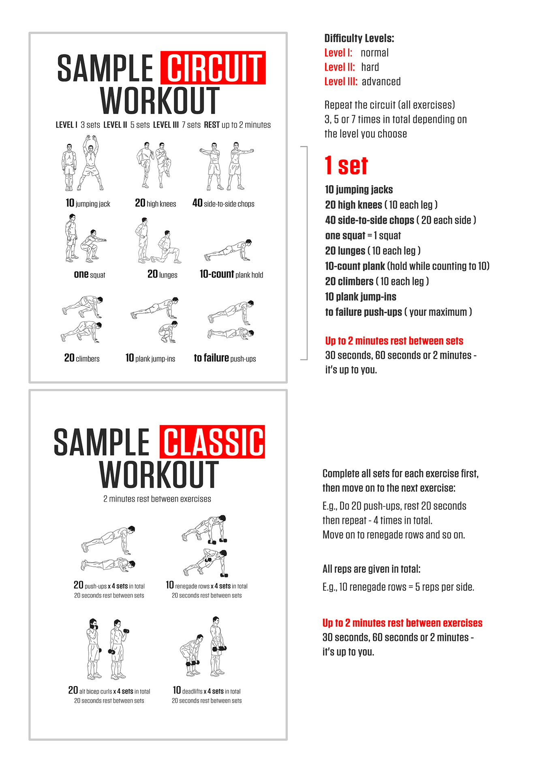

Understanding Reps

**Reps**: Refers to the number of repetitions. For example, “20 climbers” means 20 total, counting both legs: 20 = 10 per leg.

**Switching Sides:**  
**For strength workouts**: Switch halfway.  
**For cardio workouts**: Switch every rep.  
**For combat workouts**: Switch halfway for technique, every rep for speed/agility.

**Reps to Failure or MAX**: Perform as many reps as you can until you can't do more maintaining a proper form.

**Reps Throughout the Day**: Complete the total reps over the course of the day, breaking them into smaller sets.

**Reps +**: You need to complete the minimum number of reps (e.g., 5+) to move to the next exercise. You can do more if it's too easy.

**Transitions Between Exercises:**  
Effective transitions between exercises help target specific muscle groups more intensely. For example, transitioning from a plank to push-ups without resting in between keeps the intensity high.

**Combos:**Some workouts involve "combinations," where two or three exercises are done in succession. For example: “3 combos: 10 high knees + 2 push-ups.” Complete the first combo, then repeat it the number of times indicated before moving to the next exercise:

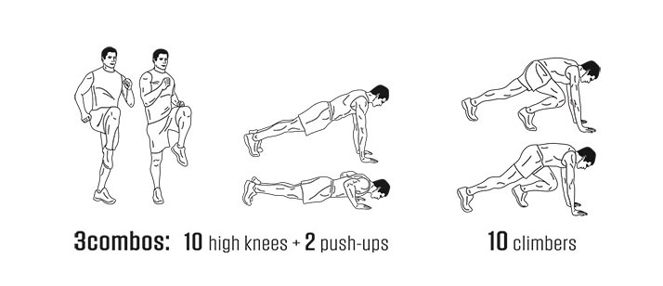

Rest Time

**Circuit Workouts**: No rest between exercises - only after completing a set. Rest after the entire circuit before repeating.

**Classic Workouts**: Rest time is listed for each exercise.

**Rest Time Guidelines:**  
Level I: Up to 2 minutes  
Level II: 60 seconds or less  
Level III: 30 seconds or less